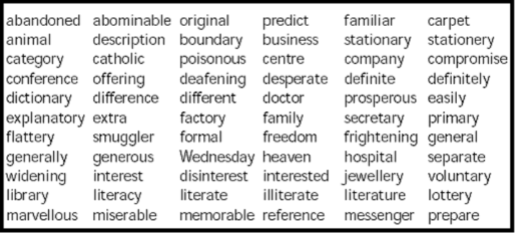
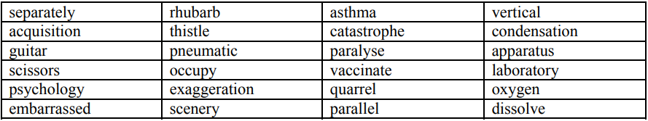
KS2 CROSS-CURRICULAR WORDS AND DEFINITIONS
luminous | emitting or reflecting usually steady, suffused, or glowing light
transparent | allowing light to pass through so that objects behind can be distinctly seen.
translucent | allowing light, but not detailed shapes, to pass through; semi-transparent.
opaque | not able to be seen through; not transparent.
source | a place, person, or thing from which something originates or can be obtained
spectrum | a band of colours, as seen in a rainbow, produced by separation of the components of light
magnetic | capable of being attracted by or acquiring the properties of a magnet.
repel | when the magnetic pole or electric field force (something similarly magnetized or charged) away from itself
unbalanced | not equal
civilisation | the society, culture, and way of life of a particular area.
abandoned | having been deserted or left.
ancient | belonging to the very distant past and no longer in existence.
whistle | device that makes a shrill sound
vibration | something moving to and fro very quickly
volume | loudness
pitch | how high or low a sound is.
eardrum | a membrane inside the ear.
tuba | low pitched brass musical instrument.
friction | When something rubs against something else
sarcophagus | A stone coffin carved with intricate detail
archaeologist | A person who studies ancient civilisations by digging for the remains
gravitational | The force of gravity (adjective)
resistance | resisting something

