microorganism | confederate | commiserate
aesthetic | anaesthetic | anagram
auxiliary | invertebrate | perceptible
treacherous | unprecedented | ventriloquist
determiner | bilious | asparagus
apparently | amphibious | saccharin

CHALLENGE WORDS
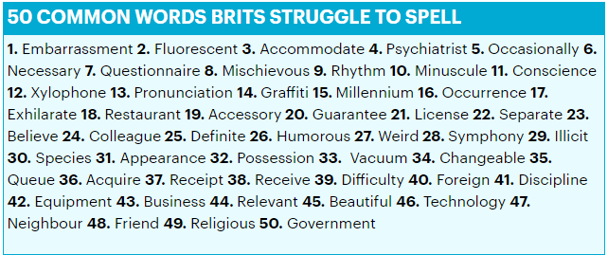
You may be asked to correctly spell the following homophones, in context. Learn the rules.
practice | practise | device
devise | council | counsel
stationery | stationary | desert
dessert | compliment | complement
principle | principal | affect
effect | ascent | Assent
licence | license

EXTRA CHALLENGE:
AUXILLARY, SABOTAGE, CHASM, CLIQUE, CORRESPONDENCE, PRETENTIOUS, SURVEILLANCE, SOLILOQUY, CELESTIAL, DEFAMATION, VEXATIOUS, QUIZZICAL

